**Lab 15: Patching EXEs with Ollydbg**

**Course Name:** Malware Analysis and Reverse Engineering (IAM302)

**Student Name:** Nguyễn Trần Vinh – SE160258

**Instructor Name:** Mai Hoàng Đỉnh

**Lab Due Date:** 11/3/2023

**Purpose**

* To practice disassembling and modifying binaries.

**What You Need**

* A Windows machine, real or virtual. I used a Windows Server 2008 virtual machine.
* You need several files to examine. They are all in the Documents folder of the VM your instructor handed out. If you don't have that, download them with these links:
* exe
* 3EXEs.zip
* easy.zip
* 256exes.zip

**9.1: Patching an EXE (15 pts)**

**Getting the EXE**

**Checking the Hash**

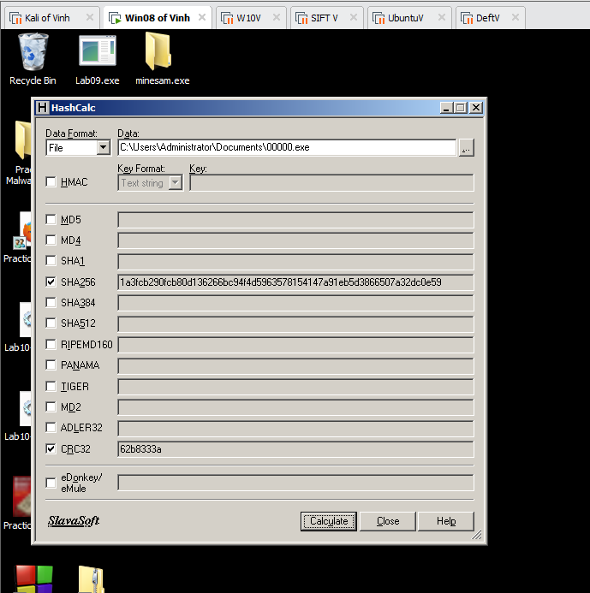

**Running the EXE**

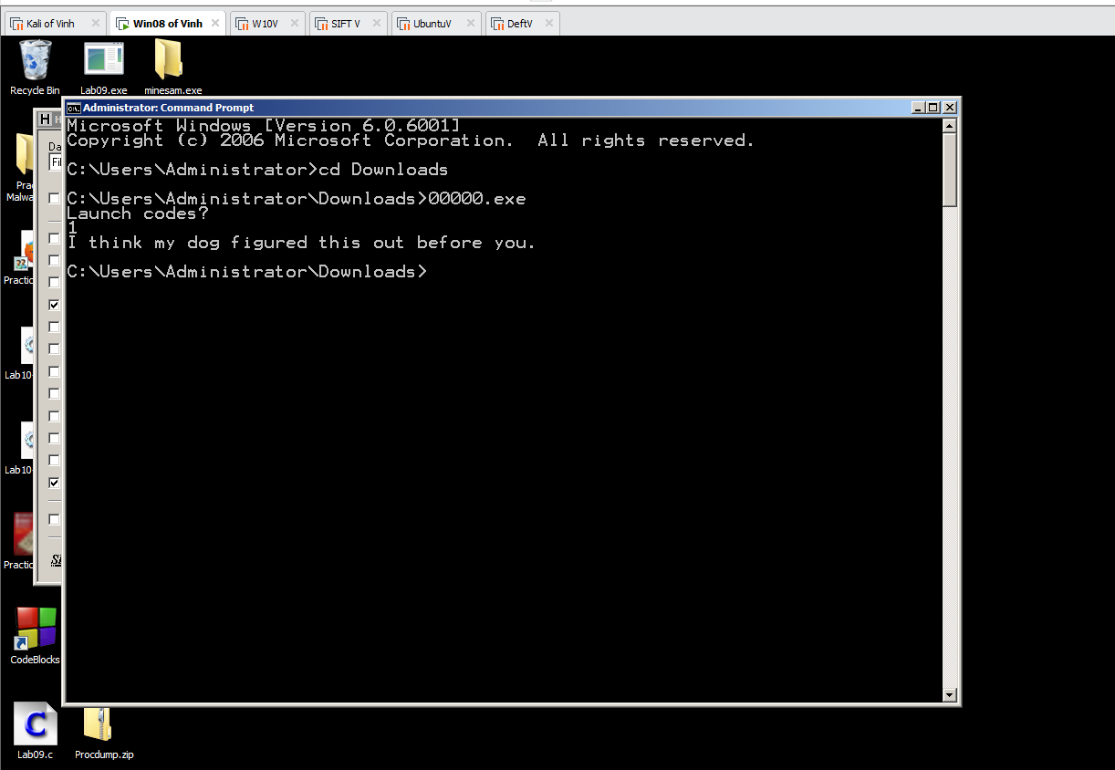

**Examining the EXE with Ollydbg**

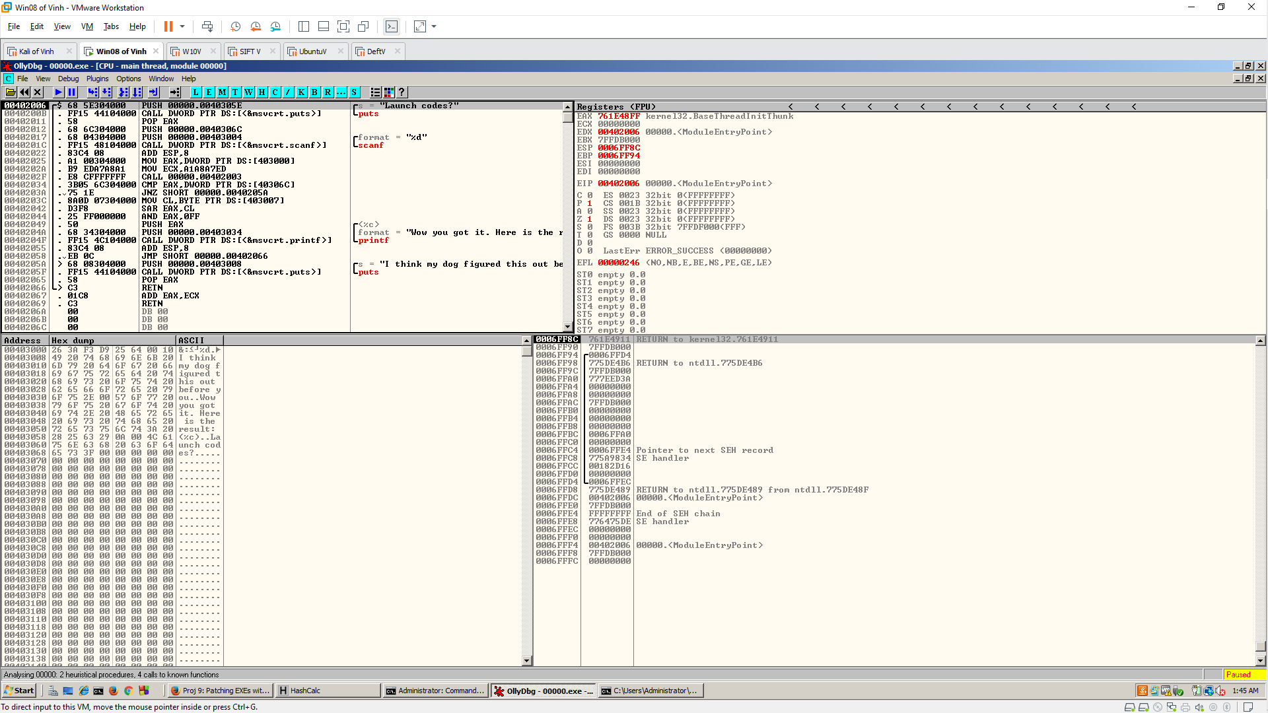

**Modifying the EXE**

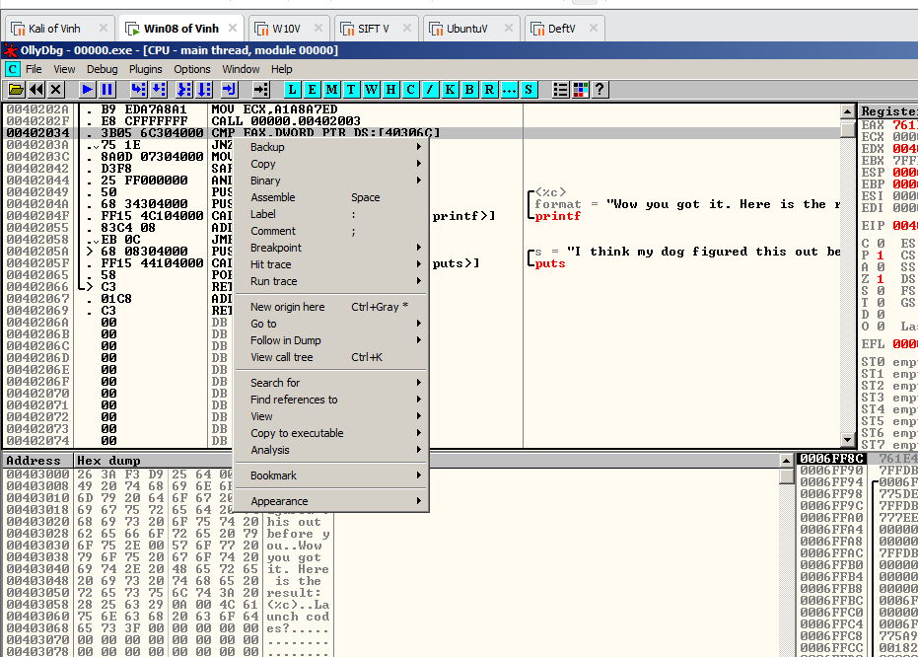

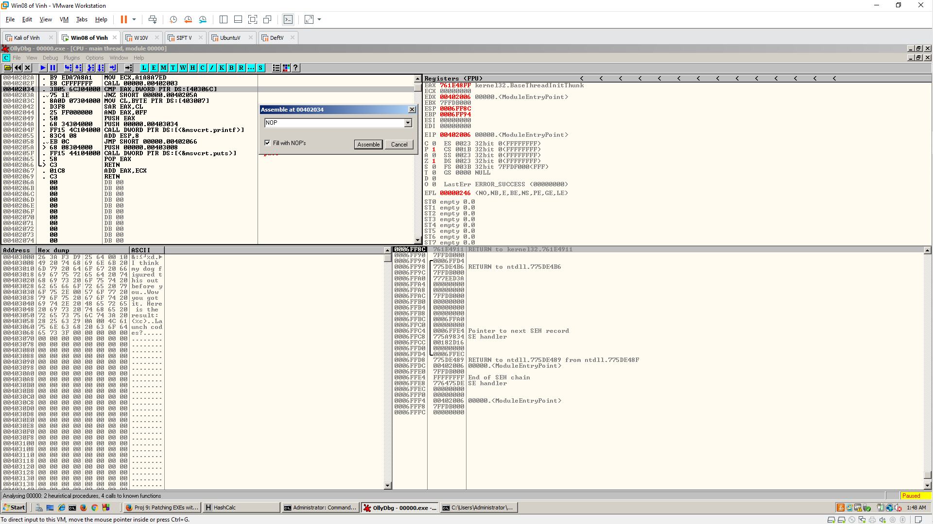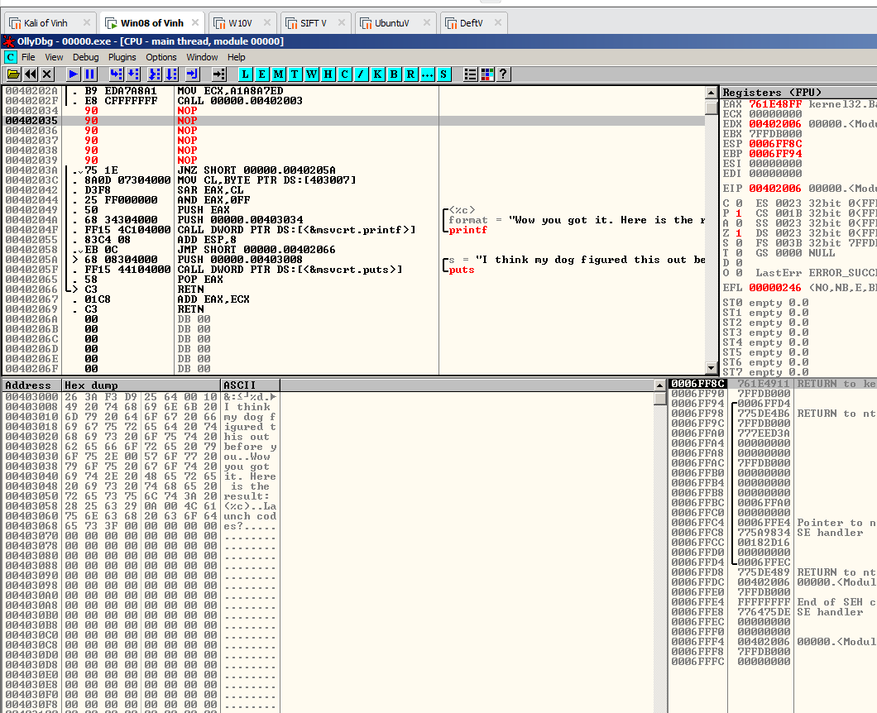

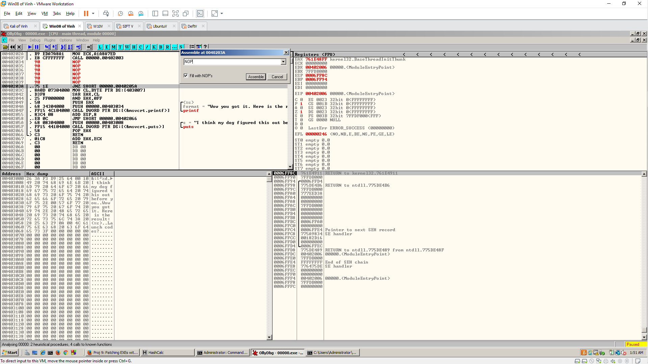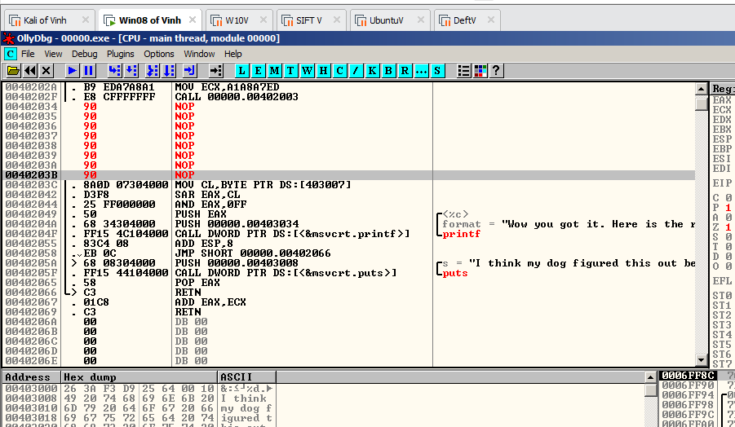

**Saving the Modified File**

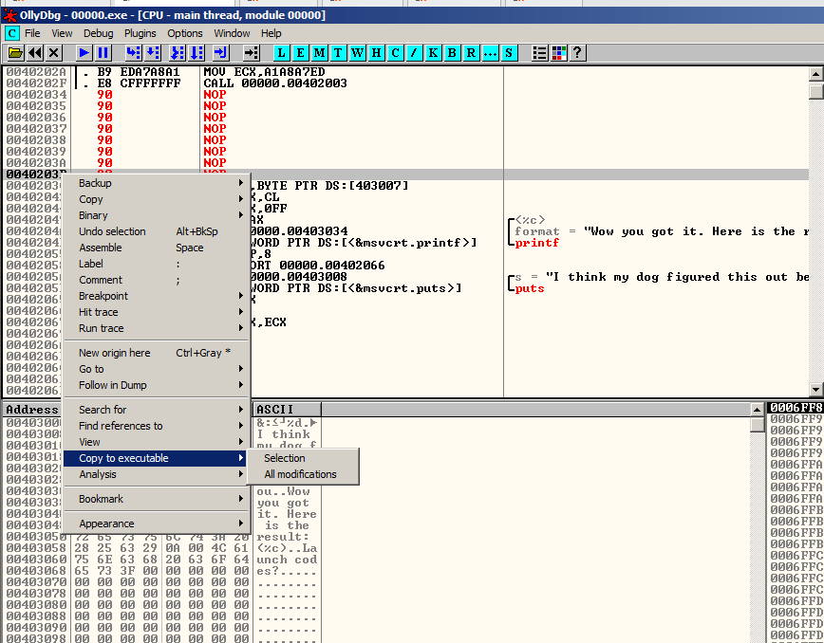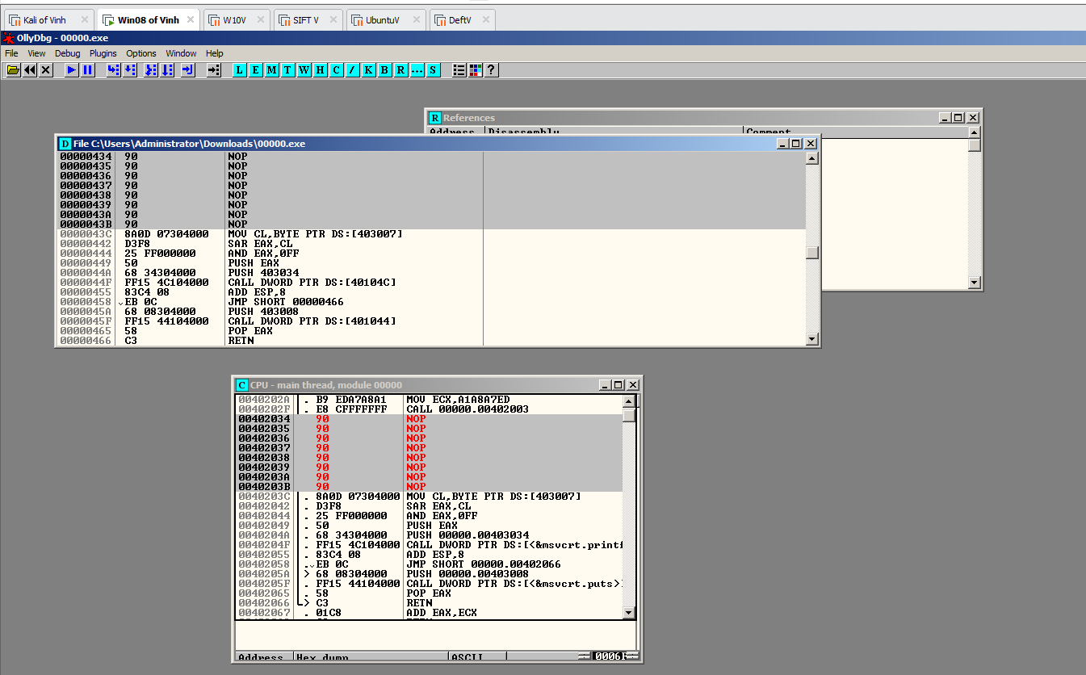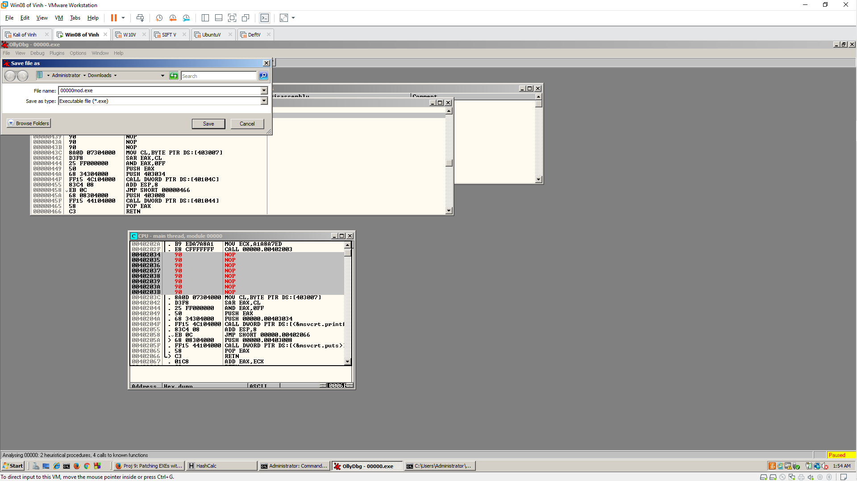

**Running the Modified File**

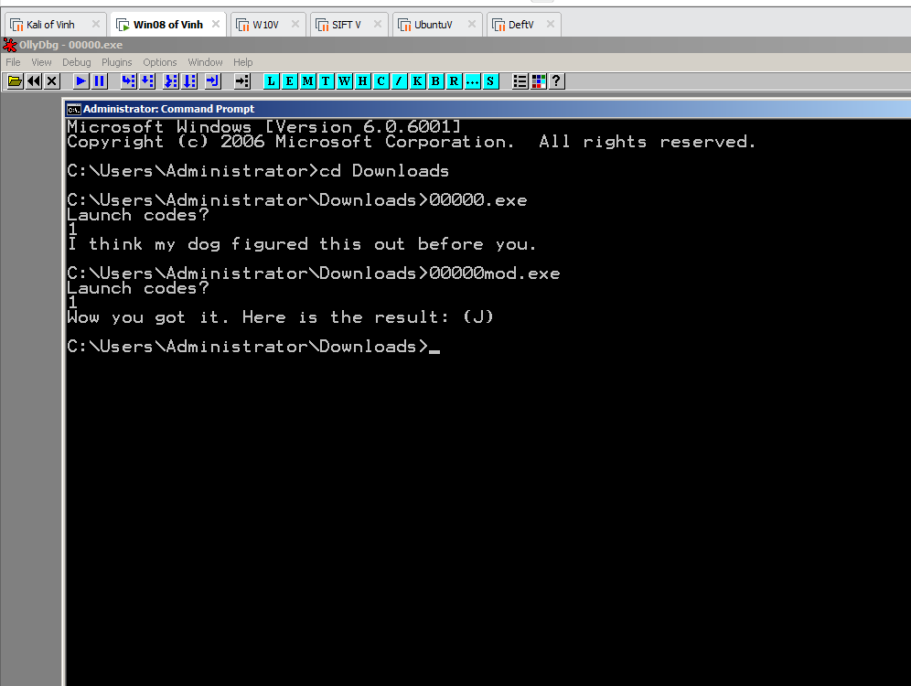

**Checking the Hash**

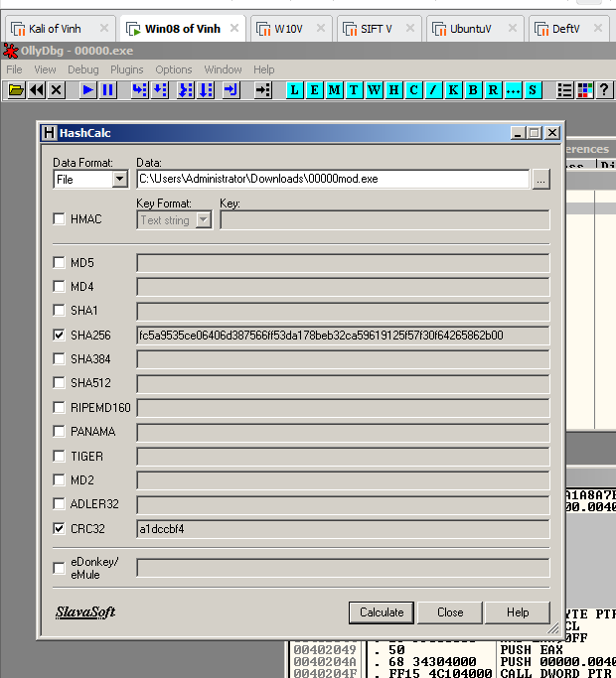

**9.2: Patching Three EXEs**

**Getting the EXEs**

**Checking the Hash**

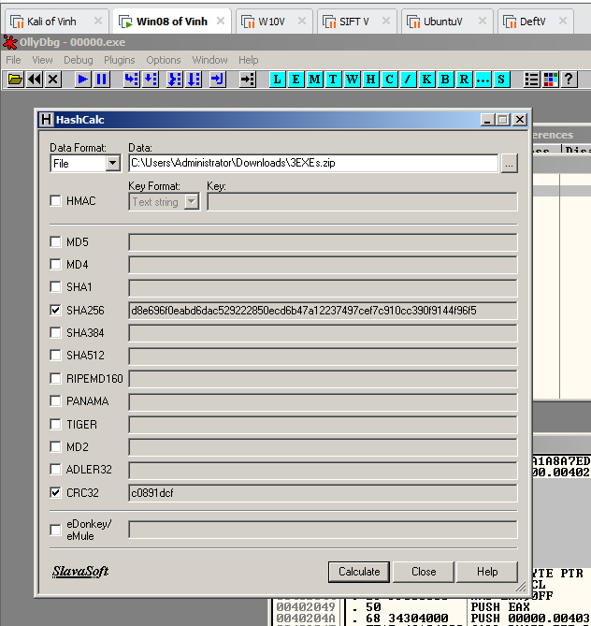

**Patch the Files**

**00000.exe**

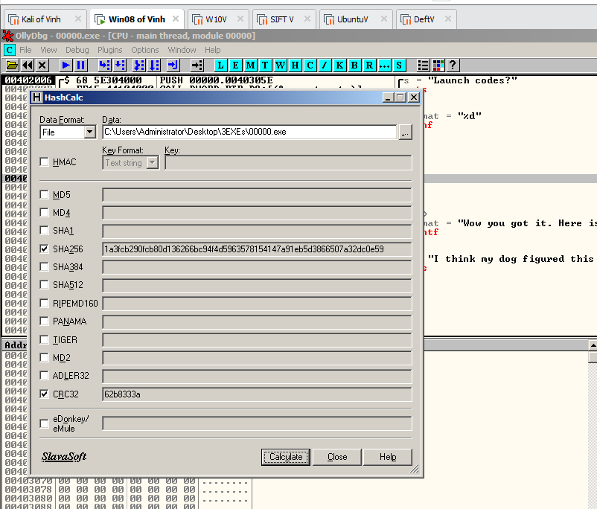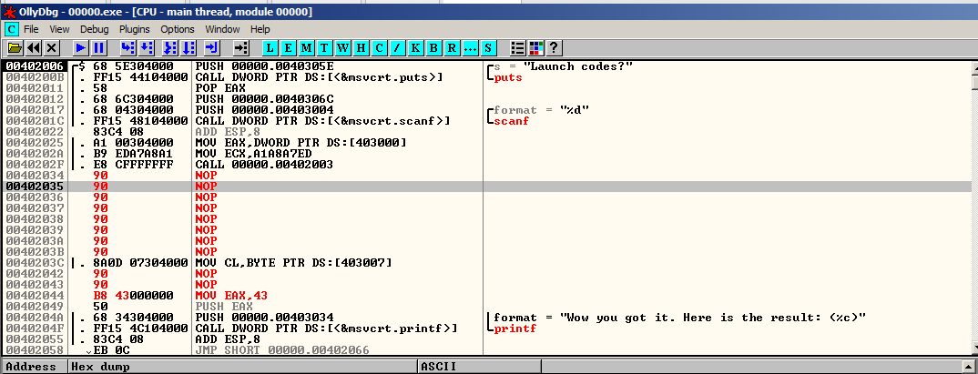

**0000a.exe**

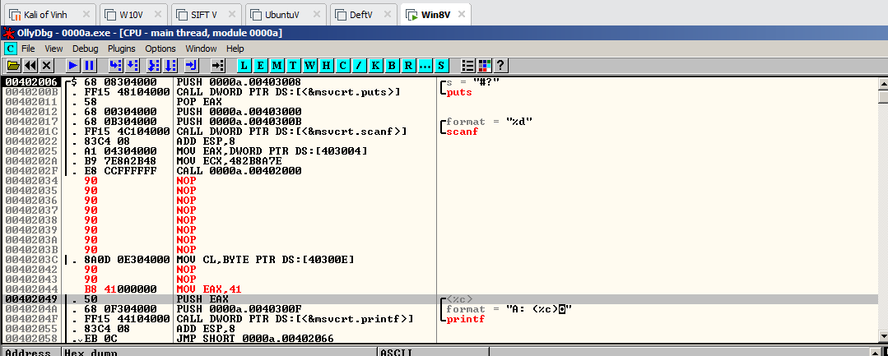

**000a1.exe**

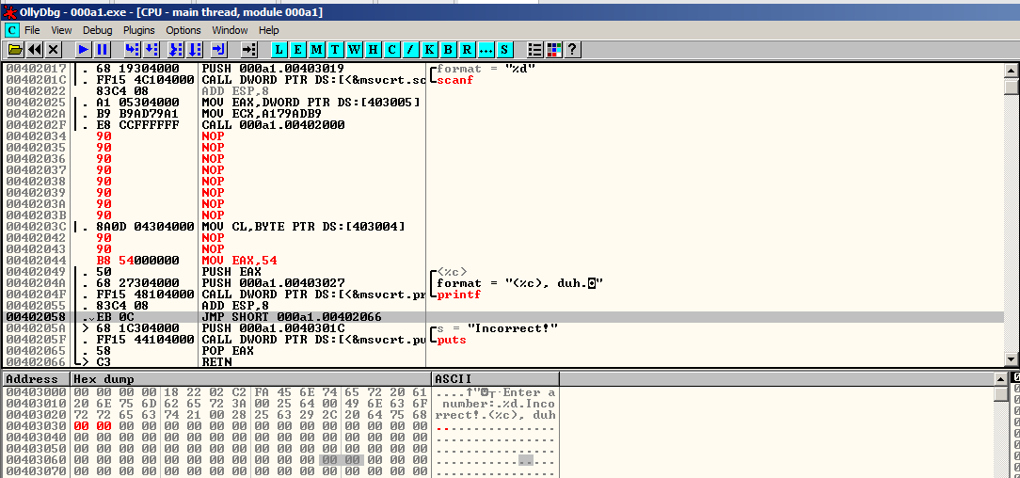

**Run file**

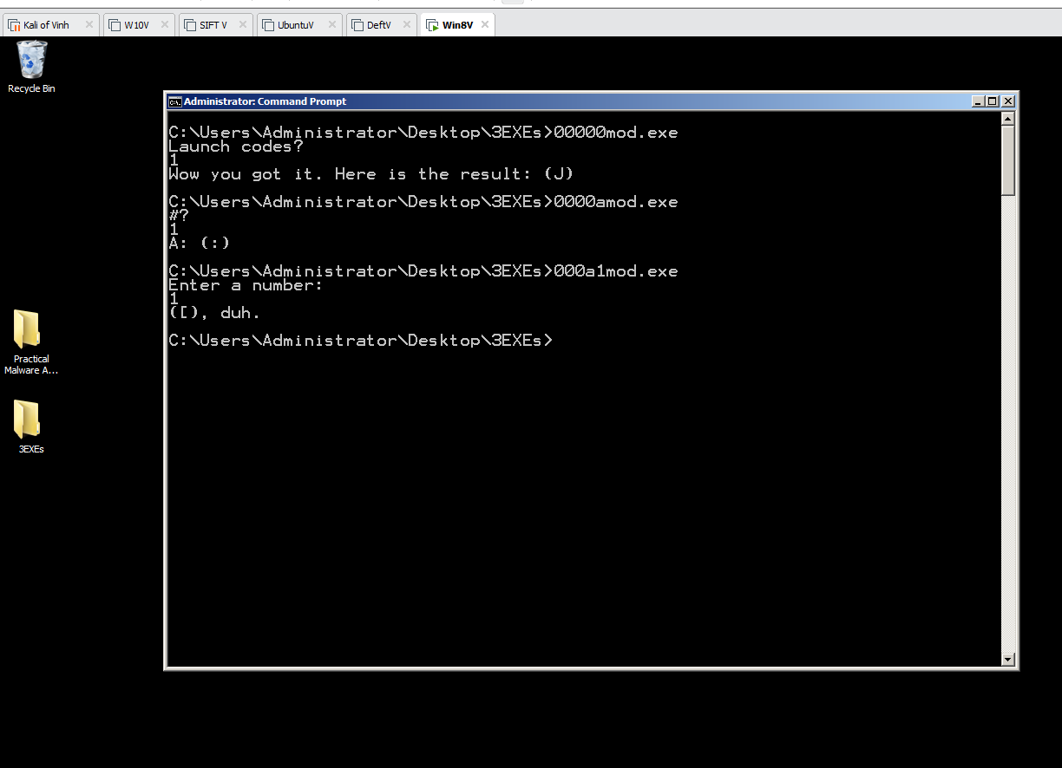

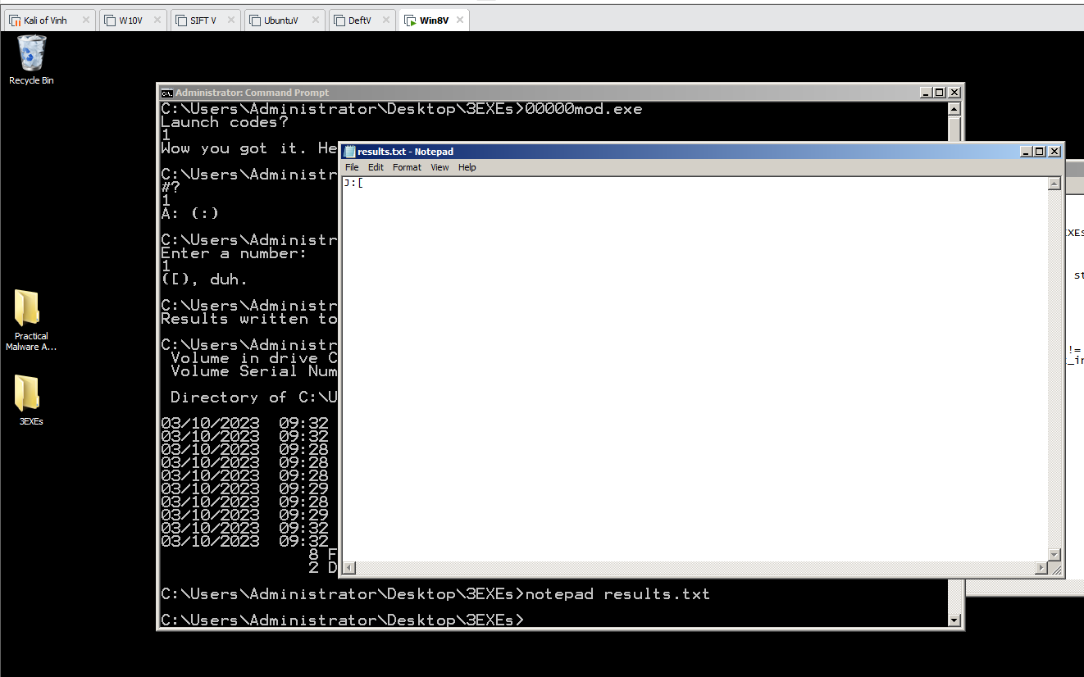

**9.3: Patching 19 EXEs**

**Making Python Run on Windows**

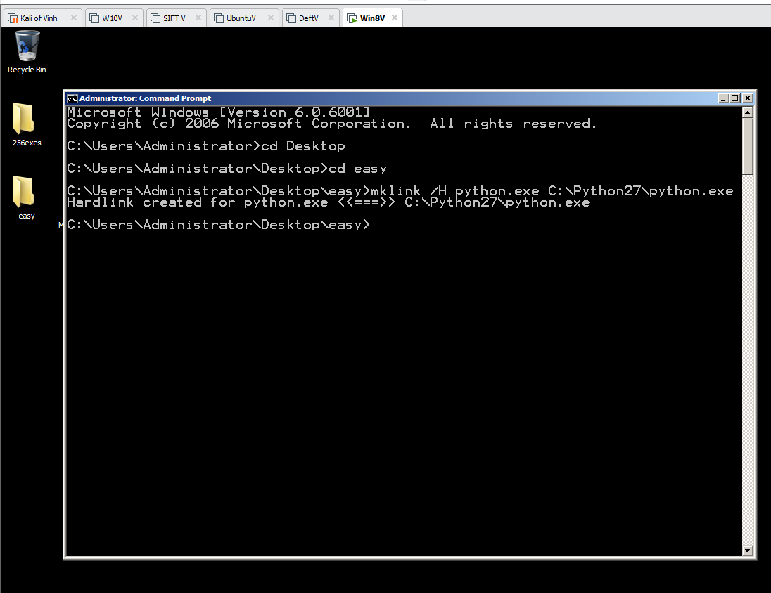

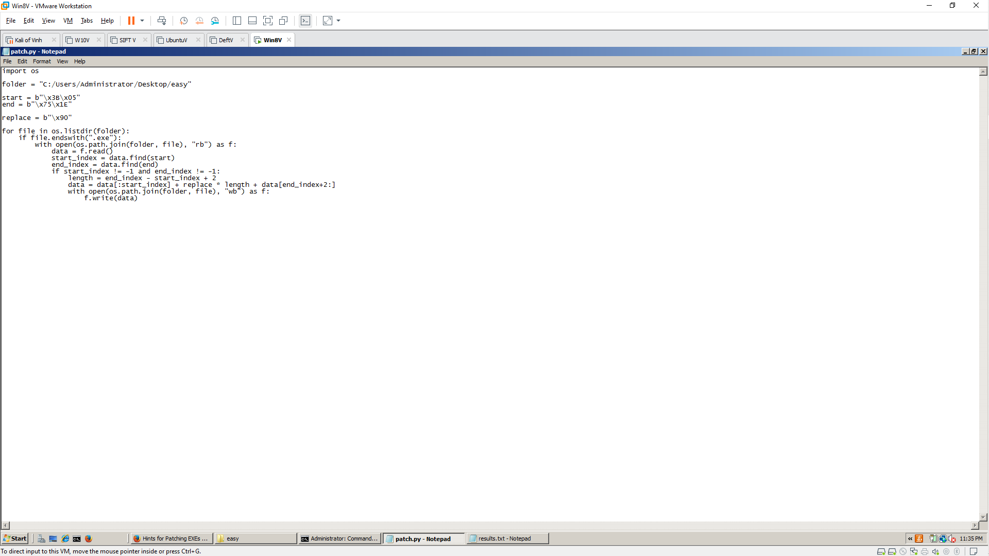

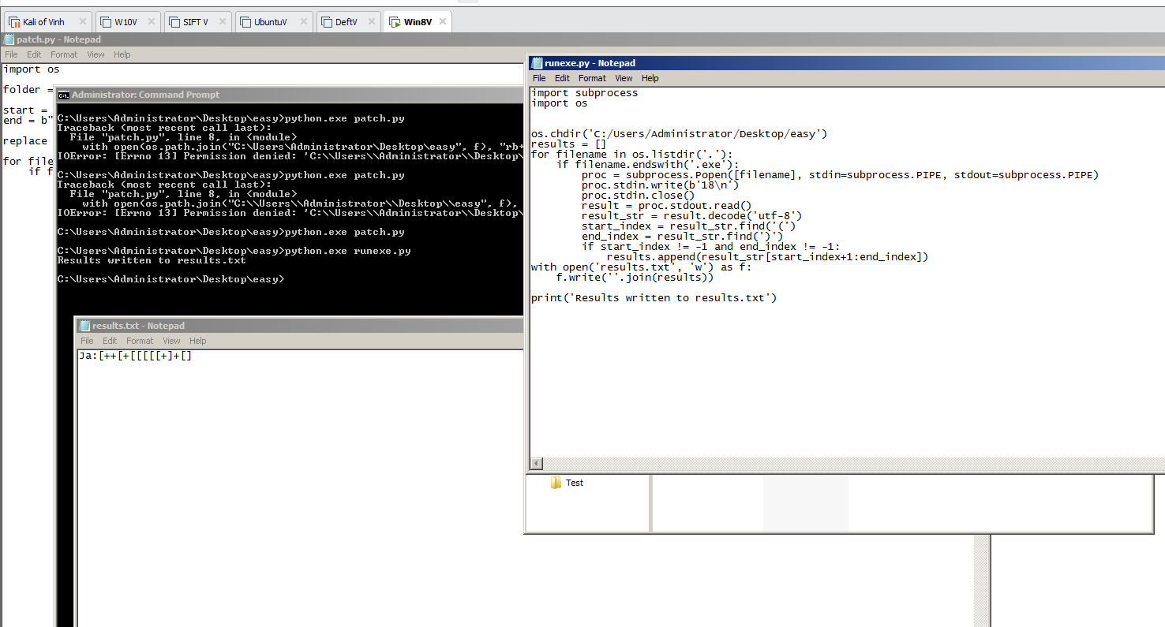

**256exes**

